LONG PROBLEMS

- A moon is orbiting a planet such that the plane of its orbit is perpendicular to the surface of the planet where an observer is standing. After some necessary scaling, suppose the orbit satisfies the following equation:
$$9{\left(\frac{x}{2}+\frac{\sqrt{3}y}{2}-4\right)}^{2}+25{\left(-\frac{\sqrt{3}x}{2}+\frac{y}{2}\right)}^{2}=225$$
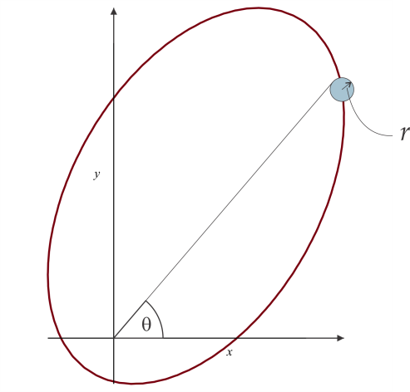
Consider Cartesian coordinates where x is on the horizontal plane and y is on the zenith of the observer. Let $r$ be the radius of the moon. Assume that the period of rotation of the planet is much larger than the orbital period of the moon. Ignore the atmospheric refraction.
Figure 1
- Calculate the semimajor and semiminor axis of the ellipse.
- Calculate the zenith angle of perigee.
- Determine $\tan{\frac{θ}{2}}$ where $θ$ is the elevation angle (altitude of the upper tangent of the moon) when the moon looks largest to the observer.

- Two massive stars A and B with masses $m_{A}$ and $m_{B}$ are separated by a distance d. Both stars orbit around their center of mass under gravitational force. Assume their orbits are circular and lie on the X-Y plane whose origin is at the stars’ center of mass (see Figure 2)
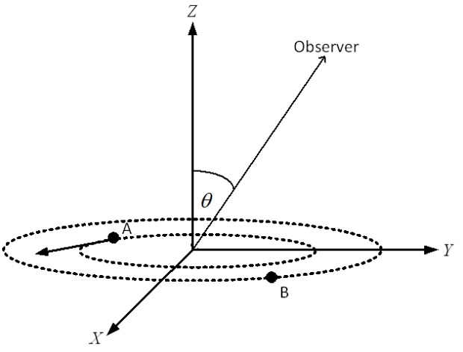
Figure 2
- Find the expressions for the tangential and angular speeds of star A.
An observer standing on the Y-Z plane (see Figure 2) sees the stars from a large distance with an angle $θ$ relatively to the Z-axis. He measures that the velocity component of star A to his line of sight has the form $K cos\left(ωt+ε\right)$, where K and $ε$ are positive.
- Express $K^{3}/ωG$ in terms of $m_{A}$, $m_{B}$ , and $θ$ where G is the universal gravitational constant.
Assume that the observer then identifies that star A has mass equal to $30M_{S}$ where $M_{S}$ is the Sun’s mass. In addition, he observes that star B produces X-rays and then realizes that it could be a neutron star or a black hole. This conclusion would depend on $m_{B},$ i.e.:
i) If $m_{B}<{2M}_{S}$, then B is a neutron star; ii) If $m_{B}>{2M}_{S}$, then B is a black hole.
- A measurement by the observer shows that $\frac{K^{3}}{ωG}=\frac{1}{250}M_{S}$. In practice, the value of $θ$ is usually not known. What is the condition on $θ$ for star B to be a black hole?

- Suppose a static spherical star consists of N neutral particles with radius R (see Figure 3).

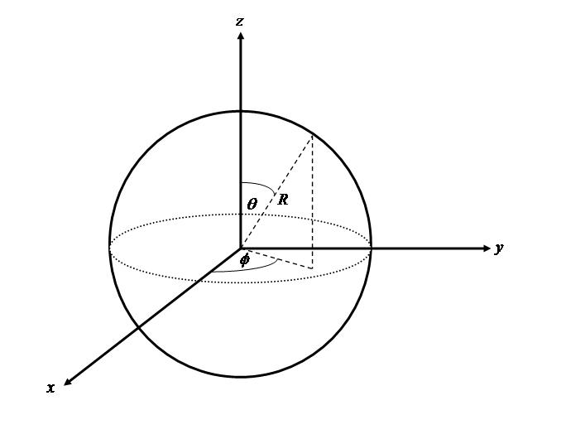

Figure 3

with $0≤θ≤π$ , $0≤ϕ≤2π$ , satisfying the following equation of states

$P V=N k \frac{T_{R}-T_{0} }{\text{ln}\left(T_{R}/T_{0}\right)}$ (1)

where P and V are the pressure inside the star and the volume of the star respectively, k is the Boltzmann constant. $T_{R}$ and $T_{0}$ are the temperatures at the surface $r=R$ and the temperature at the center $r=0$ respectively. Assume that $T_{R}≤ T_{0}$.

- Simplify the stellar equation of state (1) if $∆T=T_{R}-T_{0}≈0$ (this is called ideal star)
(Hint: Use the approximation$ln\left(1+x\right) ≈x$ for small x)

Suppose the star undergoes a quasi-static process, in which it may slightly contract or expand, such that the above stellar equation of state (1) still holds.

The star satisfies first law of thermodynamics
$Q= {ΔMc}^{2} +W$ (2)

where Q, M, and W are heat, mass of the star, and work respectively, while c is the light speed in the vacuum and $ΔM≡ M_{final}- M_{initial}$ .

In the following we assume $T_{0}$ to be constant, while $T_{R} ≡T$ varies.

- Find the heat capacity of the star at constant volume $C_{v}$ in term of M and at constant pressure $C_{p}$ expressed in $C_{v}$ and T (Hint: Use the approximation${\left(1+x\right)}^{n} ≈1+nx$ for small x)

Assuming that $C_{v}$ is constant and the gas undergo the isobaric process so the star produces the heat and radiates it outside to the space.

- Find the heat produced by the isobaric process if the initial temperature and the final temperature are $T_{i}$ and $T_{f}$ , respectively.

- Suppose there is an observer far away from the star. Using information from part c., estimate the distance of the observer from the star.

For the next parts, assume the star is the Sun.

- If the sunlight is monochromatic with frequency $5 ×{10}^{14}$ Hz, estimate the number of photons radiated by the Sun per second.

- Calculate the heat capacity $C_{v}$ of the Sun assuming its surface temperature varies from 5500 K to 6000 K in one second.

